CANPAN (provisional) Draft 6

CANPAN is intended for use with control panels and can scan 32 switches via a matrix arrangement. It can also drive 32 LEDs. It is both a producer and consumer module intended for smaller control panels.

CANPAN is a 12V DC powered module and can only be configured in FLiM mode.

The switch matrix scanning method.

The control panel switches are interrogated using a conventional diode matrix method. This allows a large number of switches to be connected with relatively little wiring. Only 12 wires for 32 switches or pushbuttons. The matrix is arranged as 8 columns and 4 rows. Each column is pulsed from 0V (low) to 5V (high) in turn on a cyclical basis. The rows are connected to the columns via a switch and a series diode. If a switch is closed, the corresponding row is taken high when the column goes high. The voltage drop across the series diode still gives a logic high with the CMOS inputs of the PIC processor. Unlike similar arrangements for keypad scanning where only one button is pressed at one time, the diodes are required as switches may remain closed. If only pushbuttons are used, the diodes may be omitted. Note: The polarity of the switch scan has been changed from that of the CANACE3 to increase the logic margin and noise immunity.

The processor firmware detects changes in the switches or PBs and sends a corresponding CBUS event. When in switch mode, a switch closure sends an ON event and a switch opening sends an OFF event. In accord with the CBUS protocol, the event is a 32 bit (4 byte) number. The upper two bytes are the Node Number. The lower two bytes are the node event (switch number). By default for CANPAN, these numbers start at 1 and run sequentially to 32. With the present PIC code, it is possible to allocate different events to individual switches which supplant the default values. If these are taught as ‘short’ events, you can give each switch a ‘device number’ which may be useful for PC operation. This alternative allocation requires FLiM mode and a suitable configuration tool over the CBUS network.

Each switch can be configured individually for its mode of operation. There are four options.

- ON / OFF as would be used for toggle switches.
- ON only. Used for pushbuttons to send just ON events.
- OFF only. Used for pushbuttons to send just OFF events.
- ON / OFF alternate. Used by pushbuttons for ‘push on, push off’.

The switch mode (SV) is the value set in EV3 at the time of teaching. The switch number must be known prior to this and is entered in EV2. If teaching a switch, EV1 must be set to 1.
Teaching of a switch event follows the same process as teaching the LEDs using EVLRN (OpCode 0xD2) and, if required, all EVs can be taught as part of the same process.

The value of the switch mode byte (SV) also allows a switch event to change the LEDs directly. When used in mode 4, an external event with the same value as the switch event will change the ‘toggle’ state. Hence pressing a PB in this mode will always give a state change even if it has been changed previously by an external device such as a CAB or other control panel.

Figure 1 shows the switch connections and numbering. If on / off switches are used, a series diode is required between the columns and the switches as shown in Figure 2. It is recommended that U2 is a 74HC238 but if a 74HC138 is used, the diode polarity must be reversed. If pushbuttons are used, diodes are not necessary but may be included in case more than one PB is pressed at once. (Also the PIC code needs changing for a 74HC138)

Figure 1 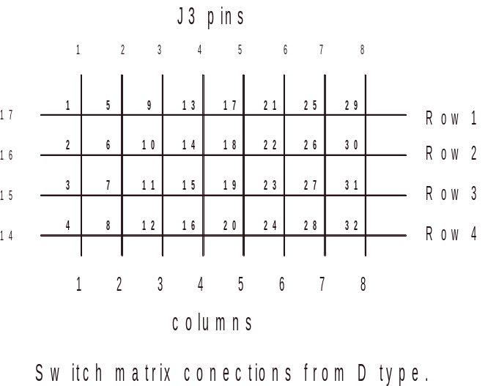

Figure 2 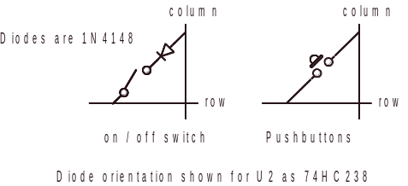

The LED outputs.

The CANPAN uses a similar scheme to the CANLED module with a multiplex arrangement of 4 rows and 8 columns. The LEDs are connected with the anodes to the row lines and cathodes to the columns. The overall brightness may be set with a single resistor.

As in the CANLED64, any or all LEDs can be ON, OFF or flashing for each event. Each LED also has a polarity bit so if an event sets one LED ON and another OFF and the flashing is also enabled, they will flash alternately. Teaching the LEDs requires a sequence of EVs for the event starting now at EV5. EV13 is the mode for that event.

The LED connections and numbering are shown in Figure 3. The PCB also has a 26 way box header on it. The pin numbering is the same for both this header and the 25 way D type socket.

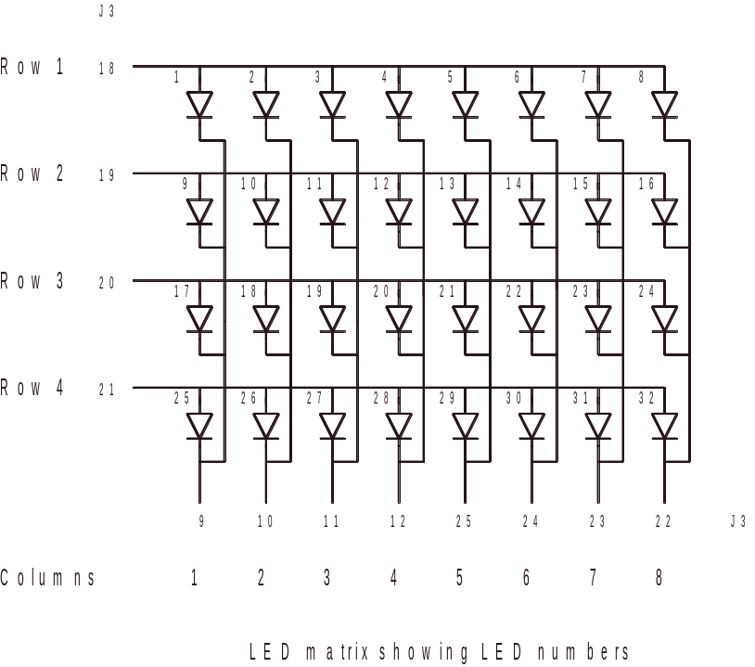
Figure 3

Configuring in FLiM mode.

On first power-up, the CANPAN will have the green LED illuminated and requires connecting to the FCU. Hold in the small PB on the PCB till the green LED goes out. Release the small PB and the yellow LED will flash. The FCU will recognise the CANPAN and give it a Node Number. You also give the module a ‘name’. The yellow LED will go steady and it is now ready for teaching. Switch events and LED only events are taught using EVLRN. For a LED only event, EV1 must be 0. For a switch event, EV1 is 1. EVLRN uses an indexed method for the EVs and you can only teach one EV at a time. EV1 should be taught first and, for a switch event, EV2 must be the switch number and EV3 the switch variable. It is essential to teach a value for EV3 as the switch event is only transferred to the switch table when EV3 is entered.

Once a switch event has been entered, you can change just EV3 (the SV) at any time using EVLRN and an index of 3.

The bits for this byte are as follows.

Bit 0 Set if an ON / OFF action
Bit 1 The polarity bit. Set to reverse the polarity
Bit 2 Set for ON only. For OFF only set this bit and the polarity bit.
Bit 3 Set for pushbutton ON/OFF alternate.
Bit 4 Set to send to own LEDs
Bit 5 Set to send a short event.
Bit 6 Not used when teaching. It is the toggle state while operating. A ‘0’ is on.
Bit 7 Not used when teaching. If set, it indicates a taught event.

If bit 0 is set, it overrides bits 2 and 3.

The event allocation process is arranged so a user doesn’t need to know the switch number (position in the matrix) in advance. The sequence is as follows.

Put node into learn mode <0x53><NNhi><NNlo>

Now activate the switch to be taught. You can operate a switch as many times as you like or even change which switch. The FCU needs to recognise the switch number.

The CANPAN will respond to a switch activation with a ARON1. This is a request response so it will not activate anything by mistake. The data byte contains the switch number with numbers starting at 1.

<0xB3><NNhi><NNlo><ENhi><ENlo><switch number>

The configuration utility will now know which switch has been activated by reading the switch number byte. The values returned for the node and event number here will be whatever is the current event allocated to that switch. The default is the NN of the module as allocated by the FCU and the event number is the switch number in the matrix. However, you can allocate any event to any switch, including the same event to more than one switch if you really wanted to.

Now send the event you want associated with that switch. You can teach any event, including duplicates of events from other modules so a switch on one control panel will send the same event as on another panel. Provided bit 5 in the SV is not set (not a short event), the switch action will send the whole taught event as a long event. If you want a short event, teach it with NNhi and NNlo set to 00 00. The values in ENhi and ENlo will be the switch ‘device number’. The teaching uses the same OpCode of 0xD2.

<0xD2><NNhi><NNlo><ENhi><ENlo><EN#> ><EVval >

EV#1 = 1 (for a switch event)
EV#2 = The switch number starting at 1
EV#3 = The SV as above
EV#4 Currently not used
EV# 5 to EV#13 are the LED control EVs.

You can only teach switch events using EVLRN.

Now take out of learn mode

<0x54><NNhi><NNlo>

The switch should now send the taught event with the set action. If you want the event to also activate LEDs on the same module (SV bit 4 set), you will need to teach the LED EVs for which LEDs to operate.

Once taught, switch events will have a switch number and SV associated with them in the FCU so you can restore or change switch events by re-teaching that event with different EVs.

As there are only 32 switches, then the maximum number of switch events is 32.

You can remove a switch event once taught using the UNLRN command. This removes the event from the table and restores the default value to the switch. This is a long event which is ON / OFF with the NNhi, NNlo the node number and ENhi, ENlo, just the switch number from 1 to 32. You can also remove all taught events with NNCLR and all defaults are restored.

Teaching a SoD event.

Set EV#1 to 2. Then teach it the event from the FCU. The SoD event can be either long or short. When the module receives a SoD event, it repeats the startup sequence so setting all turnouts and LEDs to the last saved position and sending the same events onto the CBUS for other control panels, PCs etc. to recognise.

Teaching the LEDs.

This follows the same process as for the CANLED64 but for 32 LEDs. Put node into learn mode and teach using EVLRN. If teaching a ‘short’ event, NNhi and NNlo must be 00 00. Each LED event has 11 EVs. Each LED has a ‘bit’ associated with it in a set of 4 bytes. These start with bit 0 of EV5 as LED1 up to bit 7 of EV8 for LED32. A bit set makes that LED active. The next 4 EVs are the corresponding polarity bits for the LEDs. A bit set reverses the polarity of the action relative to the OpCode. Thus an event can set some LEDs on and some off. EV13 is the LED control byte. Settings for this are as follows.

EV13 = 0XFF All LEDs are on / off
EV13 = 0xFE All LEDs ON only
EV13 = 0xFD All LEDs OFF only
EV13 = 0xF8 LEDs flash

Where EV13 is 0xF8, an ON event will start the flashing and an OFF event will stop it. EV13 must always be taught, even if only a few LEDs are wanted.

For a LED only event, EV1 must be set to 0. EVs 2,3 and 4 need not be set. If you want the switch to change the LEDs on its own module (bit 4 of EV3 set), you can teach the required LEDs at the same time as teaching EV2 and EV3.

Activating the switch will automatically send the event to the LED table and it will look it up as if it were an incoming event.

The CANPAN will support 128 events. As the switch events are in the table and may or may not have associated LEDs, the value of 128 is the event total.

Note: As all events are stored in the main FLASH table, you cannot use any indexed teaching or reading methods as the lookup uses a ‘hash’ method where there is no direct relation between the event and its position in the table

Update for revision 1q and subsequent. (07/08/14)

The code now incorporates a ‘startup’ facility. This is controlled by NV1. By default, NV1 is set to 0. The CANPAN saves every switch change or toggle state in EEPROM. It is held in the SV in bit 6. A zero is an ON state and a 1 is an OFF state. It reflects the last state for an event, even if the switch is in toggle mode or the device has been changed from another node. On power-up, then CANPAN sends out events corresponding to the last state when powered off. This includes setting the LEDs on the panel if the event was taught to activate its own LEDs. This effectively restores the layout to its last known state.

As then CANPAN has default events set for all 32 switches, rather than send meaningless events, only taught events are sent on startup. A taught event is indicated by bit 7 of the corresponding SV in EEPROM. There are two other startup options set by NV1.

NV1 = 0 Send all current taught event states. (default)
NV1 = 1 Do nothing
NV1 = 2 Set all taught states to ON.

Note: As the current or last state is held in EEPROM, a SoD event will refresh all devices to their current (saved) state. If you poll an individual switch with a request event, it will send the state of that switch as a response event.

Provided the EEPROM box is not checked, you can ‘bootload’ new code while retaining all taught events and the switch variables.
Supported OpCodes
9A | ASRQ *
9B | PARAN
B2 | REQEV
B3 | ARON1
B5 | NEVAL
B6 | PNN
E2 | NAME
D2 | EVLRN
D3 | EVANS
EF | PARAMS
5D | ENUM
6F | CMDERR
70 | EVNLF
71 | NVRD
73 | RQNPN
74 | NUMEV
75 | CANID
90 | ACON *
91 | ACOF *
92 | AREQ *
95 | EVULN
96 | NVSET
97 | NVANS
98 | ASON *
99 | ASOF *
0D | QNN
10 | RQNP
11 | RQMN
42 | SNN
50 | RQNN
51 | NNREL
52 | NNACK
53 | NNLRN
54 | NNULN
55 | NNCLR
56 | NNEVN
57 | NERD
58 | RQEVN
59 | WRACK
5C | BOOTM

* Switches only

Note 1: The module ID number is 29 for the CANPAN. The manufacturer number is 165.

Note 2: Individual switch polling using AREQ and ASRQ works to give the last state of a switch as long as the switch event has been taught. In the default or cleared state, there will be no response to a request as the request event will not be recognised.

From version v1s, the module has a SoD (Start of Day) capability. Sending a tauight SoD event will cause a repeat of the startup sequence using the last known positions.

CANPAN_draft6.doc Mike Bolton 07/02/15

